Firstname Lastname
Job Title
Office/Department Name
Skaggs School of Pharmacy and Pharmaceutical Sciences
University of Colorado Anschutz Medical Campus
12850 E Montview Blvd, Aurora, CO 80045 | Mail Stop C238
E: example@cuanschutz.edu | P: 555.555.5555
Pharmacy.cuanschutz.edu

NOTE: Feel free to update the above information to fit your needs, such as adding an office number, etc.
How to update your email signature.

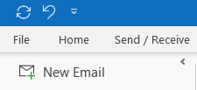
- Go to your Outlook Email.

- At the top left, click on “File”.
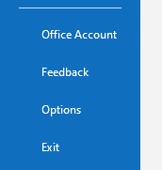

- At bottom left, click on “Options”.

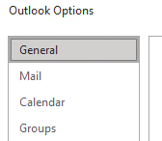
- At top left, click on “Mail”.

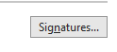
- At middle right, click on “Signatures”.

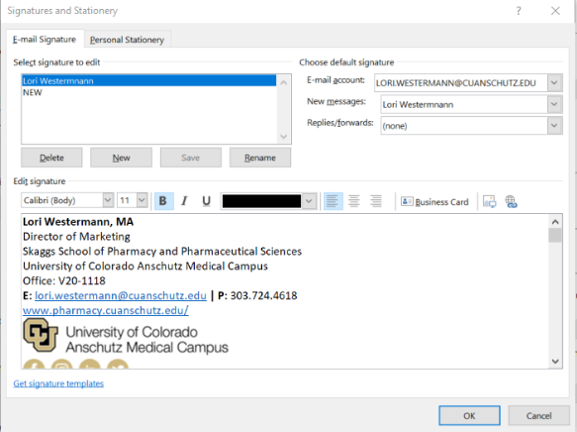
- You’ll see something that looks like this.

- Here you can either:
- Highlight and delete all your content
  - Or just delete the logo at the bottom
to avoid having to re-enter your
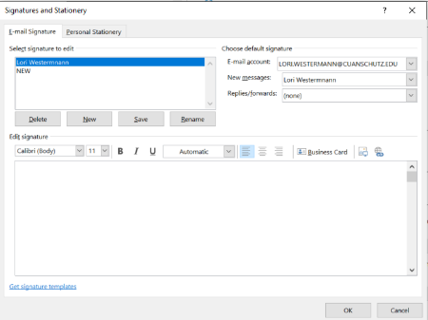
information

- You should end up with a blank box

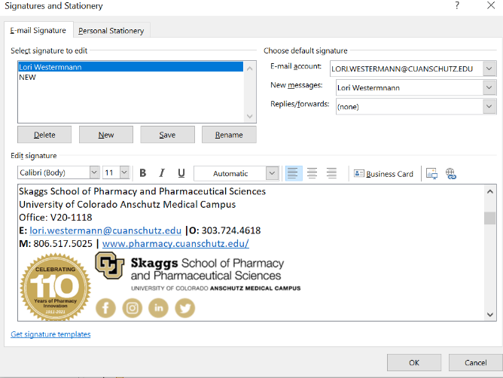
- Now, copy the new signature content and paste
Into the space.

- Select OK, close the window,
and you are all set!

If you have any problems, please reach out to sop.communications@cuanschutz.edu and we will help you!
SSPPS Office of Marketing and Communications

